Surprise Pop-up Box Card

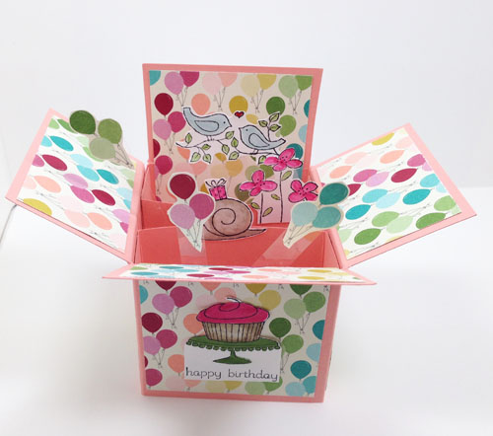

This darling surprise pop-up box was inspired by several talented stampers who took the time to create tutorials giving measurements and the details on putting the card together. Now I pass the design on to you.

SUPPLIES
Paper - One sheet of 12” x 12” cardstock, small amount of white cardstock, and patterned paper. I used Stampin’ Up!’s Crisp Cantaloupe (131195) and Whisper White (100730) cardstock and Birthday Basics Designer Series Paper (130145).

Stamps – Your choice. I used Easy Events stamp set (retired)

Inks – Assorted Classic Stampin’ Pads, Blender Pens (102845), Jet Black Stazon Ink
Pad (101406)

Other – Simply Scored Scoring Tool (122334), Sticky Strip (104294), SNAIL adhesive
(104332), Glue Dots (103683), Stampin’ Trimmer (126889), Paper Snips (103579), Bone Folder (102300), acetate Window Sheet (114323)

DIRECTIONS
- Cut cardstock at 4 ¼” x 12”. Score at 2 ¾”, 5 ½”, 8 ¼”, and 11”. Turn the cardstock ¼ turn to the left and score at 1 ¾”. See the picture below.

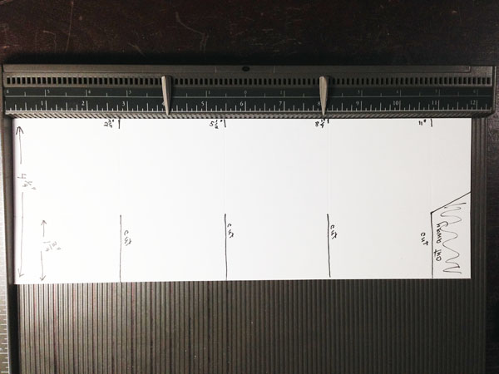

- Cut down 1 ¾” to this score line along each of the perpendicular score lines. On the 11” score line angle up to the edge of the cardstock as shown above to make a tab.
- Cut patterned paper to decorate each panel as follows:
1 inside back panel 2 ½” x 4”
3 lower outside panels 2 ½” x 2 ¼”
6 upper panels (3 inside and 3 outside) 2 ½” x 1 ½”
Cut one panel 2 ½” x 4” for the outside back panel. This is where you can sign
The card and write a greeting.
- Center and adhere each panel as shown below. Attach the longest panels to the
section next to the tab. Fold on all the score lines except for the back panel.

Outside of box Inside of box
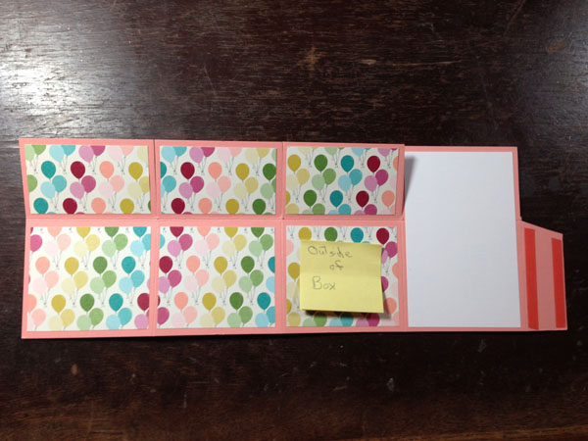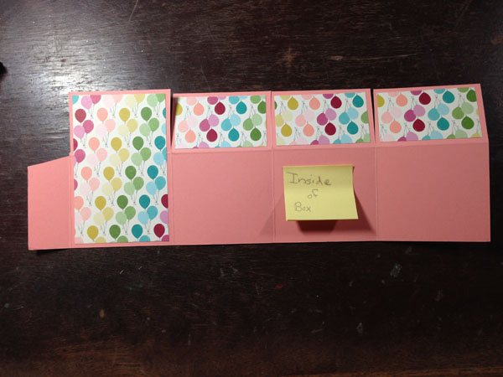

- Fold the tab to the inside of the card and apply Sticky Strip to both the scored and outside edge of the tab. Fold the card in half on the 5 ½” score line and adhere to the tab. See photo.

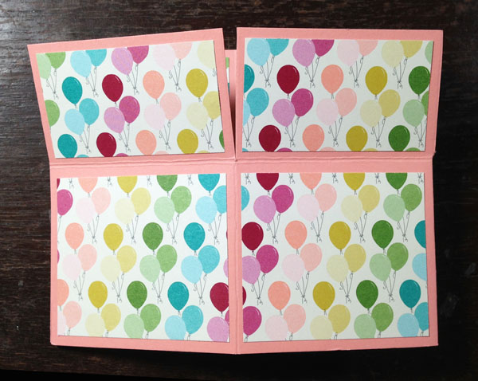

- Cut two strips of cardstock 1” x 4 ¾”. Score both ends of the strips at 1” and fold the ends back. Apply Sticky Strip to the ends. And adhere them to the inside of the box with the top edge of the strips even with the horizontal score line. The ends of the back strip line up against the back of the box and the front strip against the front of the box. See below.

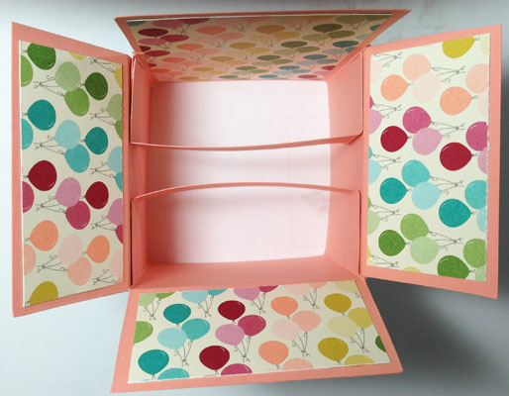

- Close the box both directions and use your bone folder to make the folds sharp so your card will lie flat for mailing.
- Adhere die cuts, stamped images and/or other embellishments to the strips, inside front and inside back of card. If desired, you can cut strips of Window Sheets (acetate) ½” x 3 ½” and attach some of your elements to them with glue dots. The strips will wave as the card is opened and the elements will look like they are floating above the card. Be sure when placing your elements that they do not stick up above the top of the card when closed or you will spoil the surprise. The stamps I chose were rather small and get sort of lost against the designer series paper. I wish I had either mounted them on punched out circles/hearts or used bigger images. But…oh well!

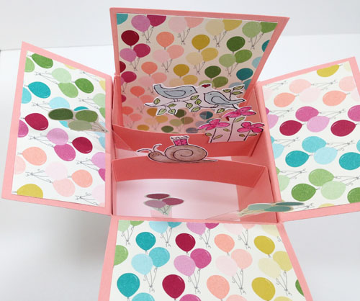

- Embellish the front inside flap if desired.

Finished card.

