Beautiful Autumn Toile Side-step Card
Sue Erickson sue@soggystamper.com

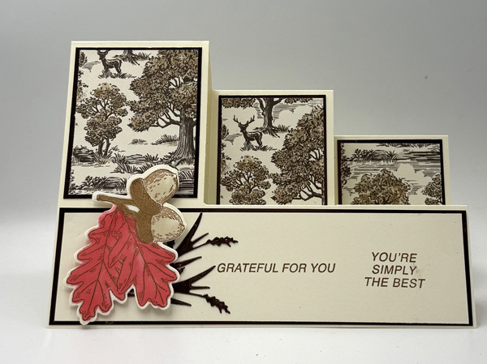
While the cutting and scoring directions may seem complicated, the final result is this beautiful card. Just follow the directions. I have tried to make them as clear as possible. If you have any questions, you can contact me at the above email. The size of the card is 5” x 7”. I doubt it would be as effective if it were sized down to 5 ½” x 4 ¼”.

SUPPLIES
Stamp bundle – Amber Autumn (165893)
Ink – Pecan Pie Classic Stampin’ Pad (161665)
Stampin’ Blends – Light Poppy Parade (154958), Dark Crumb Cake (154882), Dark Pecan Pie (161674)

Paper including cutting dimensions –
Very Vanilla Cardstock [CS](166784) 7” x 10”, 2 ¾” x 6 ¾”, scrap for focal image
Autumn Toile Designer Series Paper (165882) 1 piece 2 1/8” x 2 5/8”, 2 pieces 1 7/8” x 2 5/8”
Earthen Toned Metallic Specialty Paper (165901) 1 piece 2 3/8” x 2 7/8”, 2 pieces 2 1/8” x 2 7/8”, 1 piece 1 7/8” x 6 7/8”, scrap.

Accessories –
Paper Trimer (152392), Stampin’ Cut & Emboss Machine (149653) or Mini Stampin’ Cut & Emboss Machine (150678), Bone Folder (102300), Multipurpose Liquid Glue (110755), Adhesive Sheets (152334), Stampin” Dimensionals (104430)

DIRECTIONS
- Put the Very Vanilla CS on the Paper Trimmer with the short side against the top of the trimmer at 2 ½” and draw a pencil line down the cutting track using a mechanical pencil or very sharp pencil.
- Move the CS to the 4 ¾” and draw another line.
- Turn the CS so the 2 ½” line is parallel to the top of the trimmer. Place the edge at the 3” mark and score to the first line. Move the edge to 6” and again score just to the first line. Finally move it to 8” and score to the second line.
- Move the edge to 4” and score between the two pencil lines. Move it to 7” and score again between the two lines.
- Move the edge to the 5” mark and score from the second line to the bottom.
- Turn the CS to the short edge again with the 4 ¾” pencil line under the cutting slot and cut from 3” to 8”. Then move it to the 2 ½” line and cut from 4” to 8”. This will give you two slots on the card. See the template.
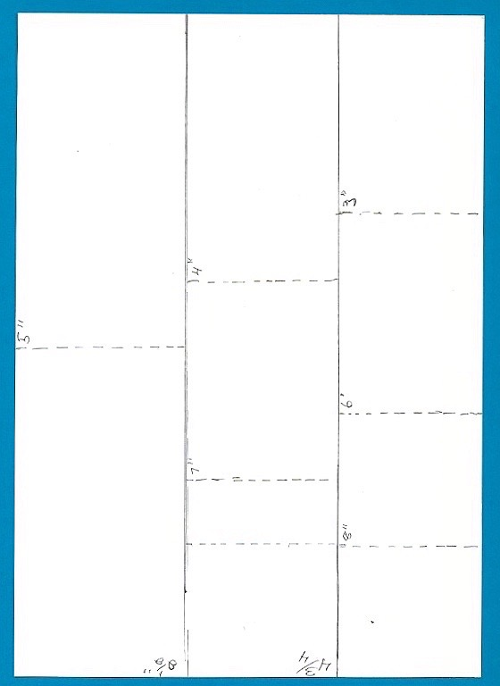
- Fold and burnish the score lines to make the steps of the card, pinch them first to start them off and then they should just fold in the correct way. See Picture.
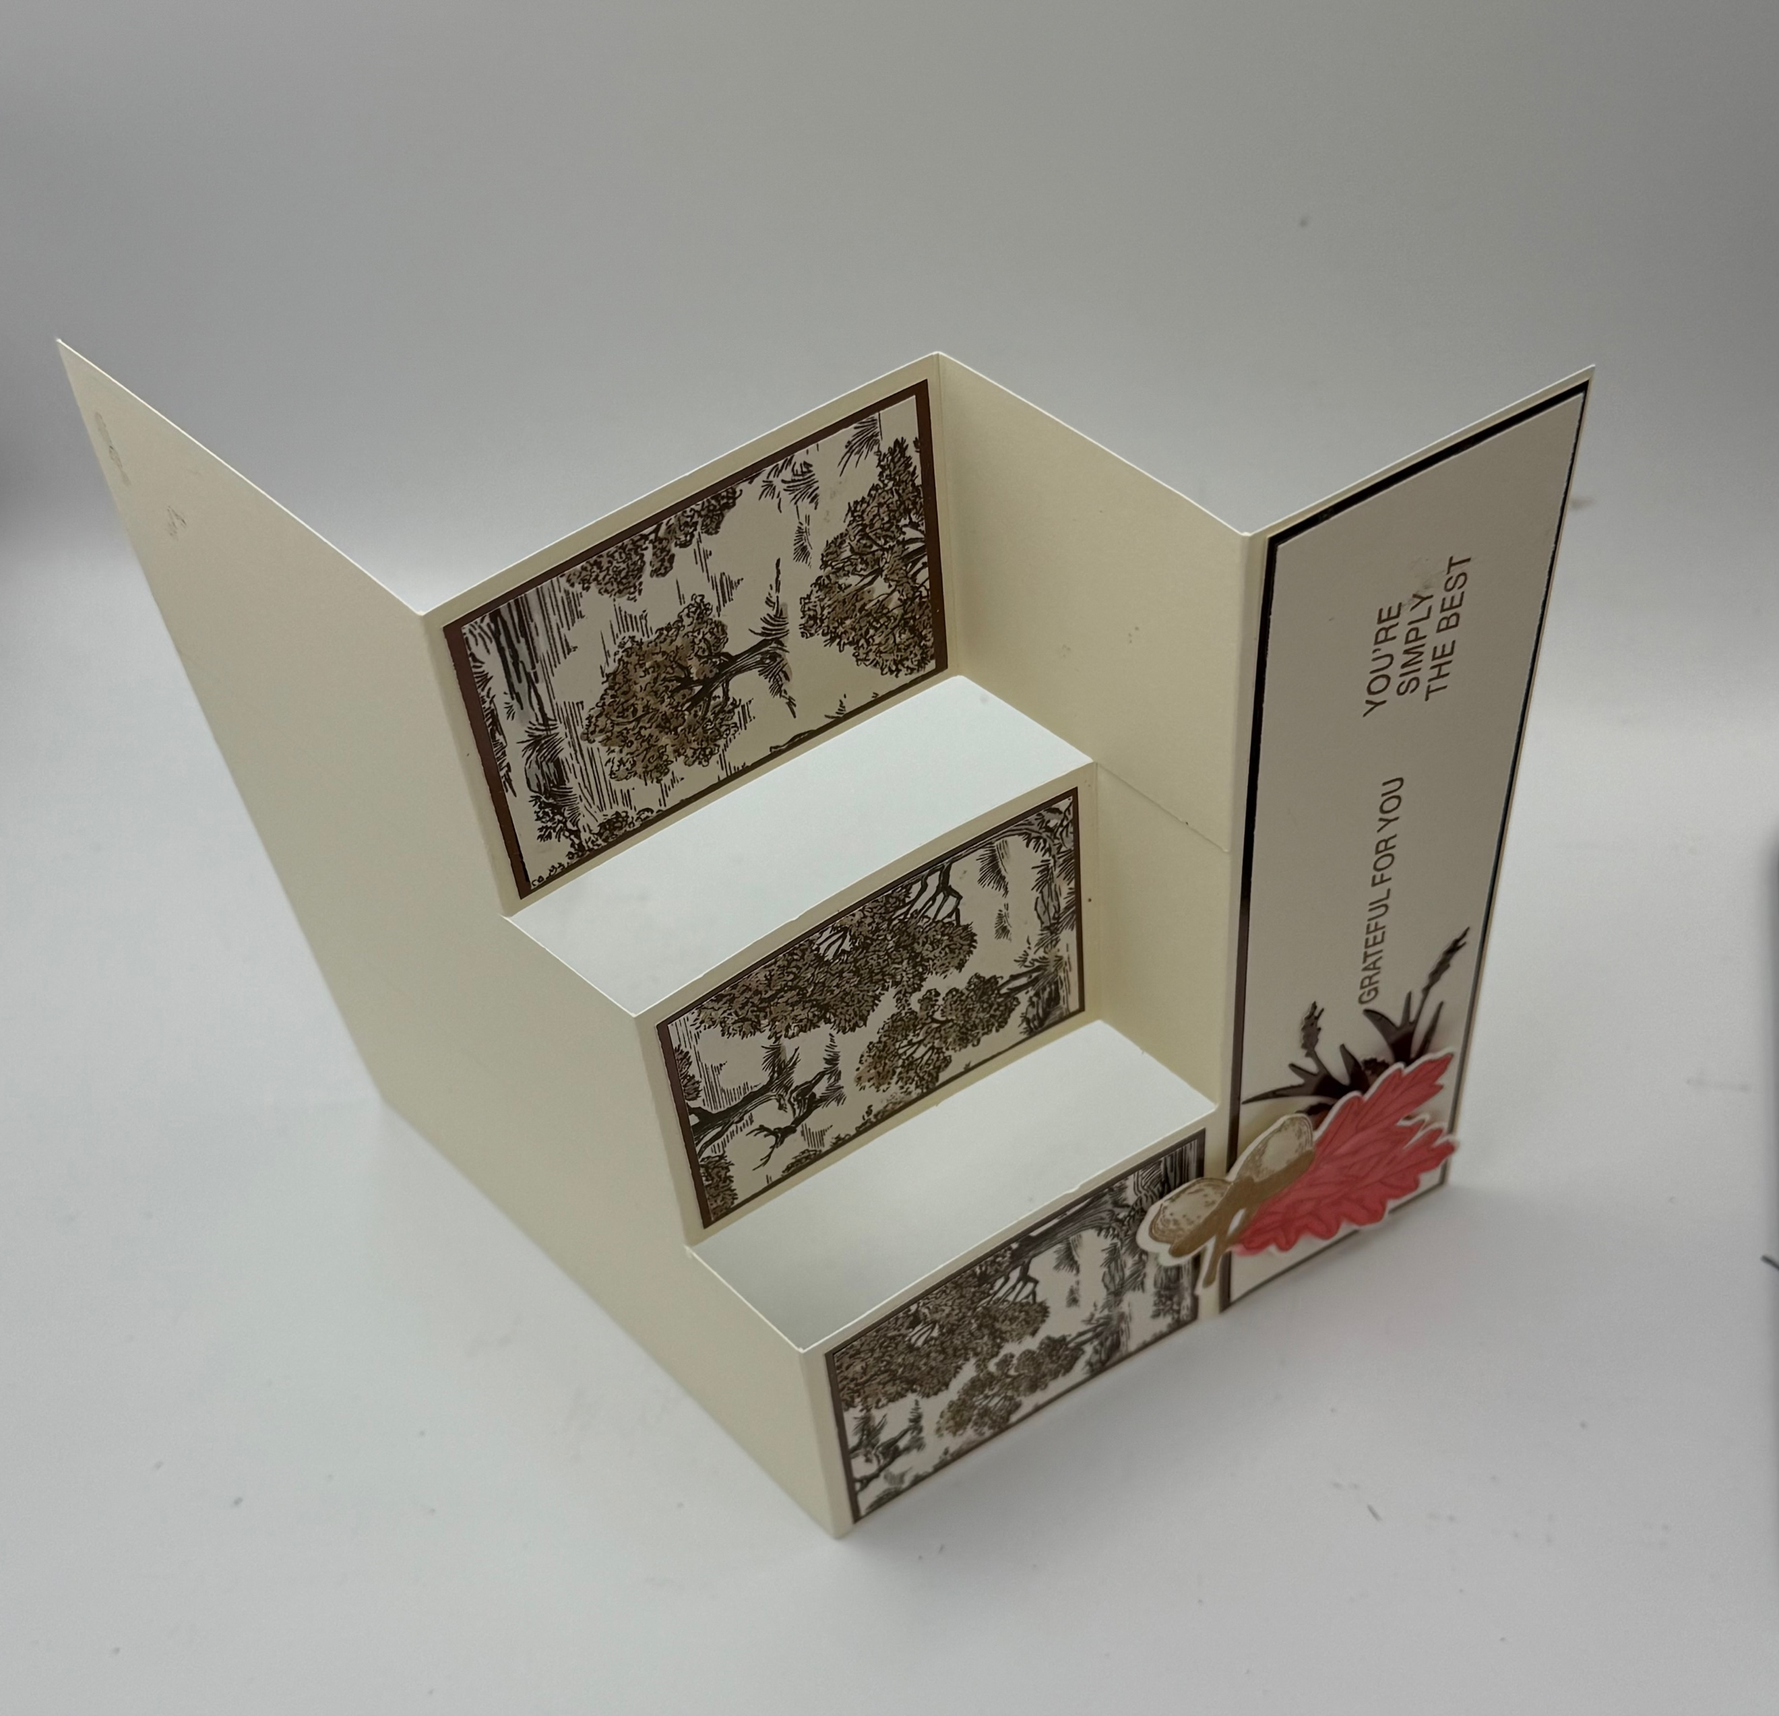
- Mat the dsp with the foil mats and adhere to card base with Multippurpose Liquid Glue.
- Position the two greetings as desired on an acrylic block and check on graph paper that they are properly lined up. Then stamp on the long piece of Very Vanilla CS using Pecan Pie ink. Then adhere to card front.
- Stamp the image on the scrap of Very Vanilla CS with Pecan Pie ink and color with the Stampin’ blends. Die-cut out.
- Apply a piece of Adhesive Sheet to back of the Earthen Toned Metallic Specialty Paper. Use the wheat die to cut one out and then turn the scrap over so the adhesive sheet is up and die-cut a second time. This way the curve of the wheat will be mirror images.
- Apply the wheat to the left of the greeting. Then apply the focal image with Stampin’ Dimensionals.

You are finished! You can write a message inside or on the back of the card.

