Traditions of Christmas Tissue Box Cover
Sue Erickson sue@soggystamper.com
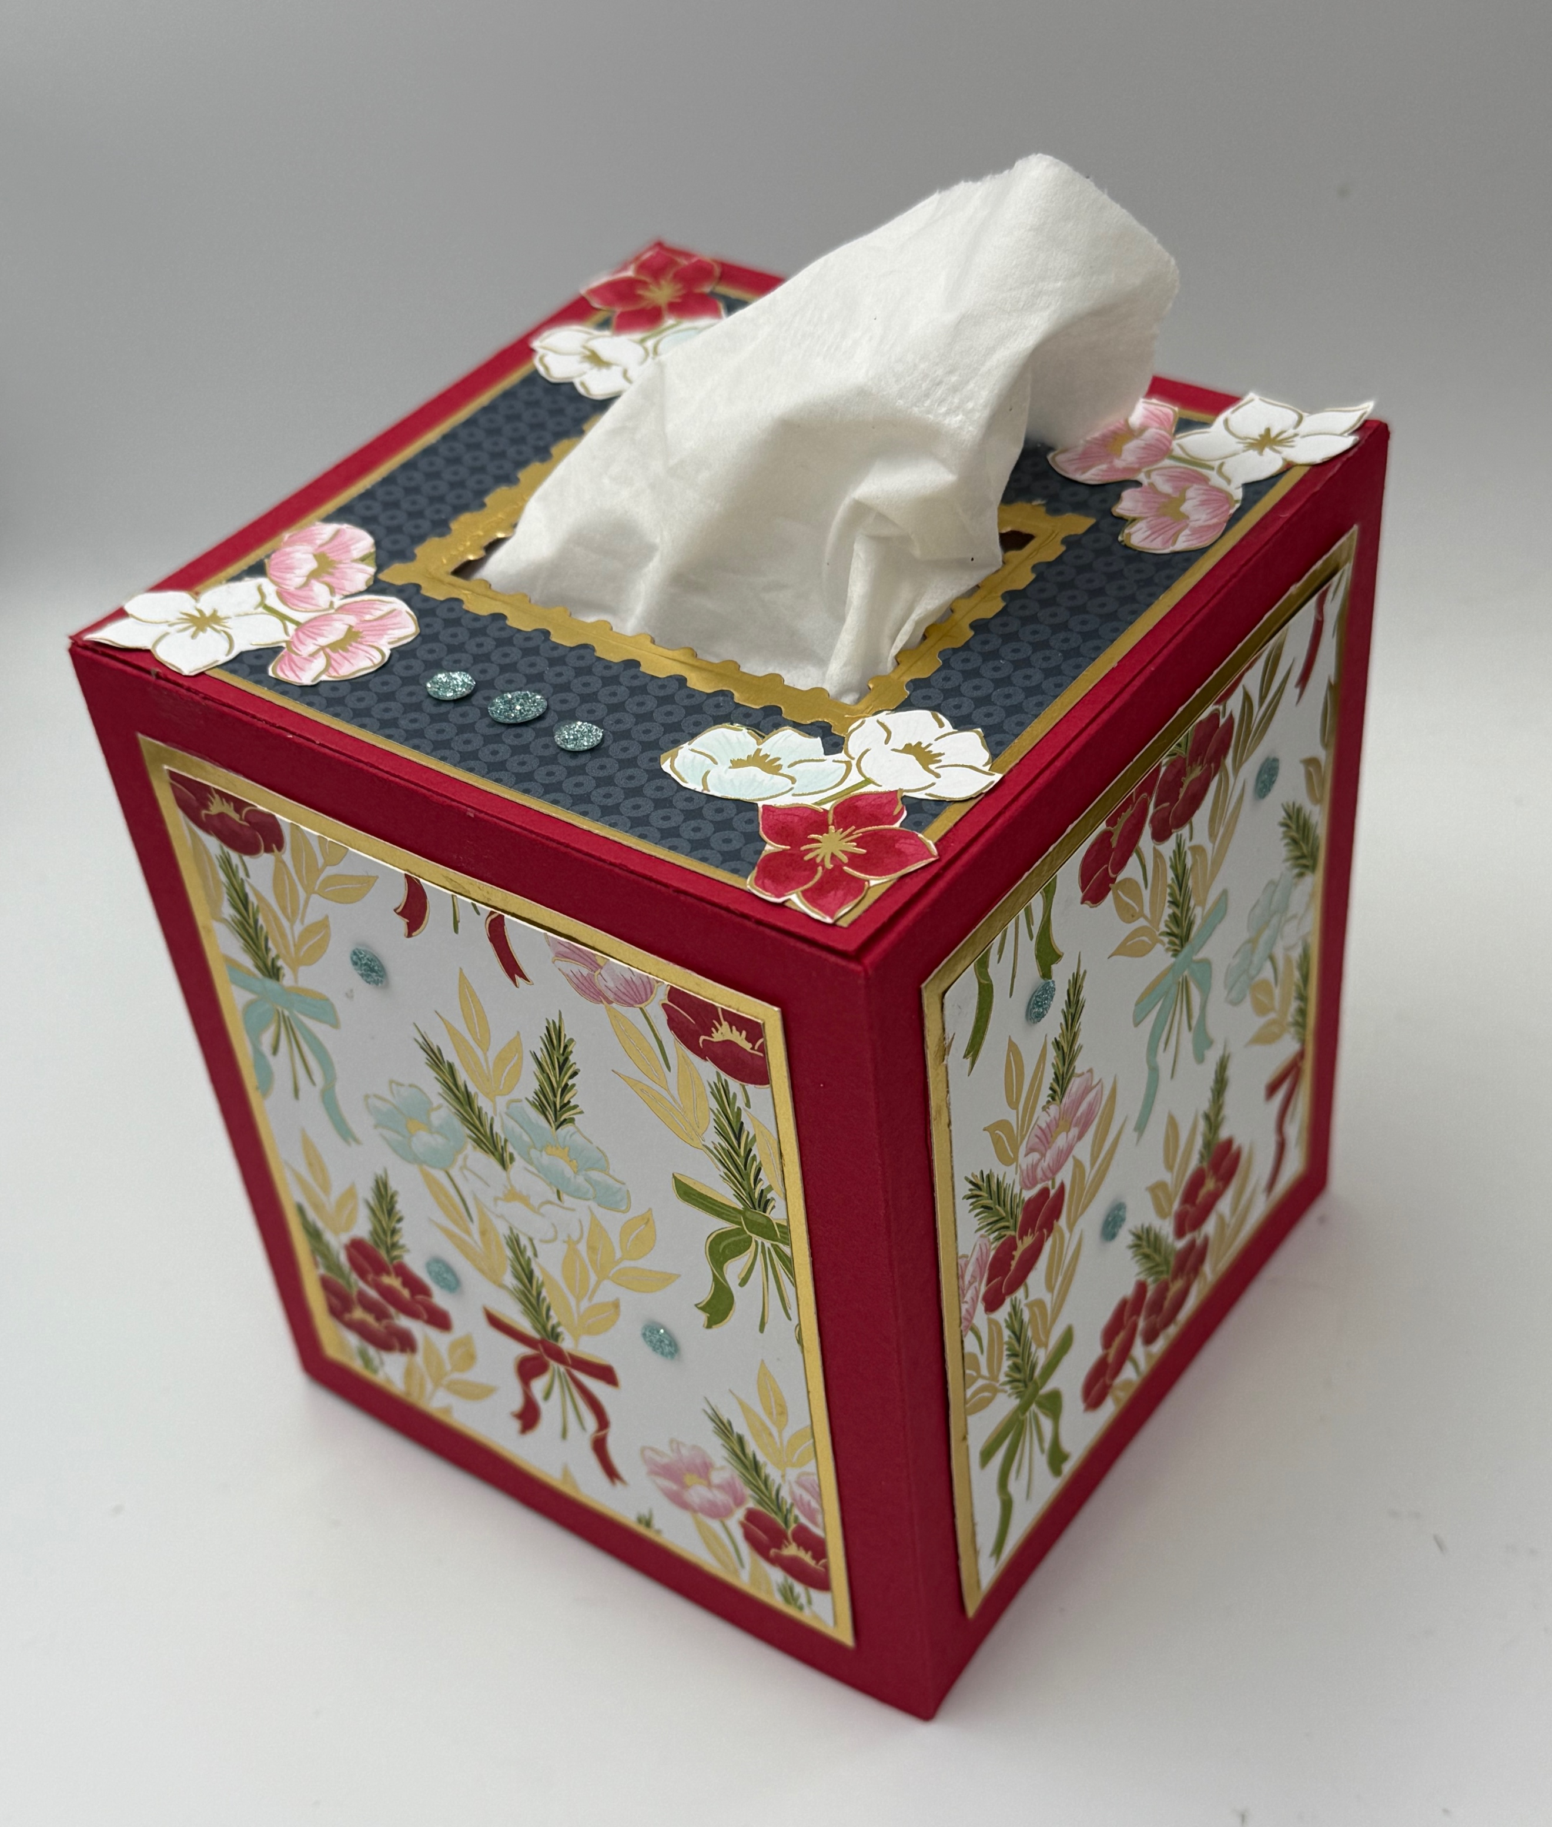
This tissue box cover fits the square Kirkland (Costco) brand tissue boxes. I suggest you measure your box if it is a different brand and adjust the pattern by adding or subtracting length at the bottom of the template and adding or subtracting width but always keeping the ½” score line at the top and at one side.

SUPPLIES
Stamp Set – Christmas Greenery (165870) optional
Inks – Whatever colors you need to color the optional stamped images
Paper including cutting dimensions -
Real Red Cardstock [CS] (102482) 2 pieces 5 ¾” x 9 ½” (sides of cover), 1 piece 4 ½” x 4 ½” for the top
Gold Foil Sheets (132622) 4 pieces 3 ¾” x 4 ½”, one piece 4 1/8” x 4 1/8”
Traditions of Christmas Specialty Designer Series Paper [DSP](165853) 4 pieces 3 ½” x 4 ¼”, 1 piece 4” x 4”, fussy cut flowers from scraps
Other – Perennial Postage Dies (162607), Traditional Sparkling Sequins (165875), Stampin’ Cut & Emboss Machine (149653), Tear & Tape Adhesive (154031) or Multipurpose Liquid Glue (110755) which is my adhesive of choice in this project, Paper Trimmer (152391, Bone Folder (102300))

INSTRUCTIONS
- Score at ½” along one long side of the two rectangle pieces of Real Red CS and at ½” on one end. Fold on the score lines and burnish well with the Bone Folder. Trim the corners at the score lines along the long side as shown in the diagram. If using Tear & Tape, apply it now to the ½” flaps.
- Layer the DSP onto the Gold Foil pieces with adhesive and then onto the sides of the box.
- Adhere the ends of the side pieces to make a box.
- Glue the square Gold Foil to the 4 ½” x 4 ½” Real Red piece and die cut the center using the third out from the smallest rectangle Perennial Postage die.
- Use the fourth out from the inside die to cut out the center of the DSP and then adhere it to the Gold Foil.
- If using Multipurpose Liquid Glue, apply it to the edges of the top and to the top edges of the sides and put the top on. I found it helpful to put the cover over a tissue box before putting the top on to give the cover more stability.
- Fussy cut flowers from the DSP or stamp and color flowers on Basic White CS and die-cut them to decorate the top of the box. If you use a flowery pattern for the top, no further decoration is necessary.
- Add some glitz with the Traditional Sparkling Sequins.

This could be sent as a gift using the Tear & Tape and shipping it unassembled with assembly instructions included.

